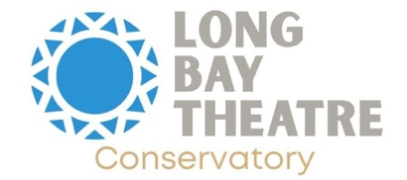
We at Long Bay Theatre Conservatory are dedicated to making sure that every child has the opportunity to explore the world of theatre. That's why we're proud to offer scholarships for our summer camps to students in need.
Thanks to the generous support of our donors, we're able to offer scholarships to students ages 6-19 who demonstrate financial need. Each session of our summer camp lasts for two weeks, with a total cost of $325.
To apply for a scholarship, please fill out the following form and provide documentation of financial need, such as a copy of the first page of your tax return from the prior year or a letter from your child's school stating that they receive free or reduced lunch. Students who attend a Title I school automatically qualify and do not need to provide additional documentation.
Please note that recipients of the scholarship are expected to pay a commitment fee of 20% of the actual tuition for each class. Additionally, students are expected to attend all classes and workshops on time, with sickness as the only excused absence.
If you have any questions, please do not hesitate to contact us at [insert contact information]. Thank you for your interest in Long Bay Theatre Conservatory's summer camps!
How did you hear about the Scholarship Program?
Student's Name: _______________________
Date of Birth: _______________________
School Attending: _______________________
Mother's Name: _______________________
Father's Name: _______________________
Address: _______________________
Email: _______________________
Age: _______________________
Cell Number: _______________________
Grade: _______________________
Sex: _______________________
City: _______________________
State: _______________________
Zip: _______________________
As scholarships are partially supported by grant funding that requires racial demographics information, please indicate your race here ____________________.
Upon acceptance, you will be emailed a promo code to register online at the scholarship price.
By signing below, I acknowledge that I have read and agree to the terms and conditions of the Long Bay Theatre Conservatory Summer Camps Scholarship Program, including the media and medical waiver.
Parent/Guardian Signature: _______________________
Date: _______________________
Theatre Conservatory scholarships are generously funded in part by our valued donors.

